Disaster Management System
By Remotz Systems

Deliverable-2

Project Team

Muhammad Moiz Ansari 23i-0523
Zohaib Umer 23i-0528
Rehan Tajik 23i-0730
Muhammad Tayyab 23i-0738

Semester 6

Supervised by
Ms. Rabail Zahid



Department of Computer Science National University of Computer and Emerging Sciences Islamabad, Pakistan
March 25th, 2026

PART A — Project Team Info

1. Team Introduction
Team Name:
Remotz Systems

Team Logo:
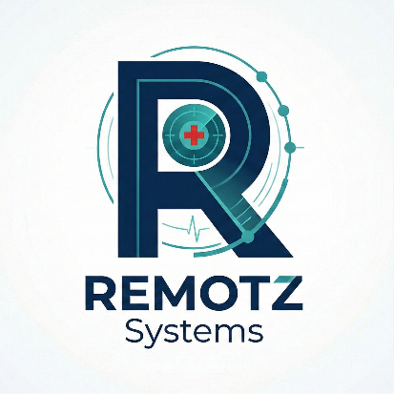

Group Picture:


2. Team Lead
Team Lead Name | Moiz Ansari
Student ID | 23i-0523
Role | Team Lead

3. Team Members

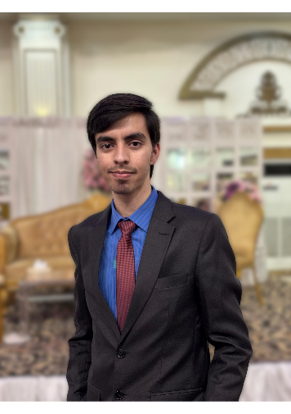
Member 1 — Moiz Ansari
Student ID: 23i-0523
GitHub Account: muhammad-moiz-ansari
Role(s): Scrum Master, UI Designer, Developer (Part-time)
Biography:
I am Moiz Ansari, a Computer Science student at FAST NUCES passionate about software development and system design. With a strong foundation in web development and UI design, my experience spans crafting custom game interfaces to engineering simple management systems like the TravelEase trip management database, focused on user-centric problem solving.

Member 2 — Zohaib Umer

Student ID: 23I-0528
GitHub Account: zohaib-umer
Role(s): Developer
Biography :
My name is Zohaib Umer. I am passionate about learning and exploring new ideas, especially in technology and computing. I have completed an internship, gaining practical experience and improving my skills. I enjoy problem-solving, reading, and working on projects that challenge me. I always strive to grow and learn.


Member 3 — Rehan Ali Tajik
Student ID: 23I-0730
GitHub Account: RehanTajik730
Role(s): Developer, Requirement Analyst / Architect
Biography:
As a dedicated Computer Science student, I specialize in C++ and possess a strong foundation in software engineering principles. I am passionate about tackling complex programming challenges and optimizing system performance. I look forward to applying my analytical skills to develop an effective management system.

Member 4 — Hafiz Muhammad Tayyab
Student ID: 23i-0738
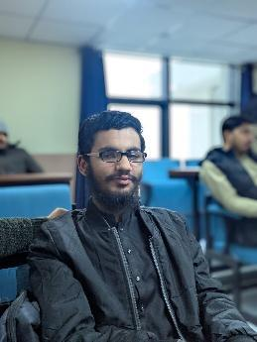
GitHub Account: TayyabMuhammad5
Role(s): Developer, Tester
Biography:
I am a motivated Computer Science student. I am passionate about software development, machine learning, and solving problems. I have practical experience in programming, using software development tools, and working on academic projects. I am excited to use my technical skills, keep up with new technologies, and contribute in team-based professional settings.

4. Role Assignments
Role | Assigned To (Name)
Product Owner / Project Manager | Moiz Ansari
Scrum Master | Moiz Ansari
Requirement Analyst / Architect | Rehan Tajik
Developer(s) | Moiz Ansari, Rehan Tajik, Zohaib Umer, Tayyab
Tester(s) | Tayyab
UI Designer | Moiz Ansari

5. Team Agreement
5.1 Methods of Communication
We will use our WhatsApp group as the primary source of quick communication, as it is mostly accessible and online for all users on multiple platforms and is used frequently. The tasks will be tracked on the Trello board. GitHub will be primarily used for code collaboration.

5.2 Communication Response Times
WhatsApp: Within 1.5 hours, Email: within 24 hours, Urgent matters: within 5 minutes

5.3 Meeting Attendance
The attendance of all group members in the meeting is necessary. The meeting will preferably be scheduled with suitable timings for all members. In case of any absentees, they will be informed about the discussion later.

5.4 Running Meetings
Online via Google Meet every Friday/Saturday at 6 PM, In-person meetings at the university on Thursdays between 1:00PM-2:30PM and in the mornings of Monday to Thursday. The Scrum Master will be responsible for taking meeting minutes and sharing them in the WhatsApp group.

5.5 Meeting Preparation
Assignment of members’ tasks, issues faced in their tasks, planning of completion of work before the deadline.

5.6 Version Control
Each feature must be committed with proper, short, descriptive commit messages. Members must coordinate with each other what they are working on to avoid merge conflicts. Each member must keep a local copy of their work as well for backups. We will avoid committing IDE-specific files, compiled .class binaries, or local environment variables.

5.7 Division of Work
The Scrum Master assigns tasks during sprint planning based on member skills and availability. All members are equally responsible for code quality. The merging or report work will be mainly handled by the scrum master but all members will contribute equally. The work will be divided among Moiz, Rehan, Zohaib, and Tayyab based on individual strengths. The stakeholders would be primarily the citizens (Main Beneficiaries), NGOs, rescue teams, and the Admin.

5.8 Submitting Assignments
Final document must be reviewed by all members 24 hours before the due date; Team Lead submits on behalf of the group.

5.9 Contingency Planning
(a) If a team member drops out: Redistribute workload and notify the instructor
(b) If a member consistently misses meetings: Formal warning then escalate to instructor
(c) If academic dishonesty: Zero tolerance, report to instructor immediately.

